|  |
| --- |
| User Manual  Procure to pay (Local) |
| REFERENCE: GW/ERP/USER MANUAL |
|  |
| **Genweb2 Ltd.** |
| **25-Aug-20** |



|  |
| --- |
|  |

# Document Information

|  |  |
| --- | --- |
| Document Name | User manual Procure to pay (Local) |
| Document Author | Rashedul Alam |
| Document Version | 1.0 |
| Release Date | 25th Aug, 2020 |

|  |  |
| --- | --- |
| Review by | Md. Mahfuzur Rahman |
| Review Date | 29th Aug, 2020 |
| Approved By |  |
| Approval Date |  |

# Document History

|  |  |  |  |  |  |
| --- | --- | --- | --- | --- | --- |
| A=Added, M=Modified, D=Delete | | | | | |
| **Version No** | **Date** | **Section No** | **A/M/D** | **Description of Change** | **Author** |
| 1.0 | 25-Aug-2020 |  | A | Initial | Rashedul Alam |
|  |  |  |  |  |  |

Contents

A. Document Information 2

B. Document History 2

1. Introduction 5

1.1 Purpose of User manual 5

1.2 Procure to pay process flow 5

2. Purchase requisition 6

2.1 Approved PR (Local) View by Purchase user (Local)/Manager 6

2.2 PR Creation by Inventory user or Manager 7

2.3 PR Validate by Plant In charge 8

2.4 PR approval by Head of procurement 9

3. Send RFQ 12

3.1 Send RFQ create by Purchase user (Local)/Manager 12

4. Comparative Bid Study 13

4.1 Comparative bid study analysis by Purchase user (Local)/Manager 14

5. View Purchase quotation 16

5.1 View Purchase quotation by Purchase user (Local)/Manager 16

6. Purchase order 17

6.1 Confirm Purchase order by Purchase user (Local)/Manager 17

7. View Purchase order 19

7.1 View Purchase order by Purchase user (Local)/Manager 19

8. Receive goods 20

8.1 Receive goods create by Inventory Manager 20

8.2 Partial Receive goods creation by Inventory manager 22

9. Quality Control 23

9.1 Quality Control create by Inventory user/Inventory Manager 23

9.2 Partial Quality control creation by Inventory manager 25

10. Sound stock 26

10.1 Sound stock Update by Inventory Manager 26

10.2 Partial Sound stock creation by Inventory manager 27

11. Vendor Bills 28

11.1 Vendor bill payment PO against initiate by Procurement user 28

11.2 Vendor bill payment validate by Accounts Executive/Manager 30

11.3 Vendor bill register payment by Accounts Executive/Manager 33

11.4 Vendor bill payment Vendor against initiate by accounts user/Manager 35

11.5 Vendor bill register payment by Accounts Executive/Manager 37

12. Reports 40

12.1 Purchase Requisition Summary Report view by Procurement user/Manager 40

12.2 Pending purchase local reports view by procurement user/ Manager 41

# 1. **Introduction**

The purposes of this User manual is to clearly identify the customer requirements and provide a detailed document. The customer will read this document and get a clear view the sales module. It will also help the review team to validate whether the customer requirements have been fulfilled or not.

## Purpose of User manual

This document is the User Manual of Commercial. It is intended to provide all the necessary information to use this software to develop application software running on the workstation.

## Procure to pay process flow

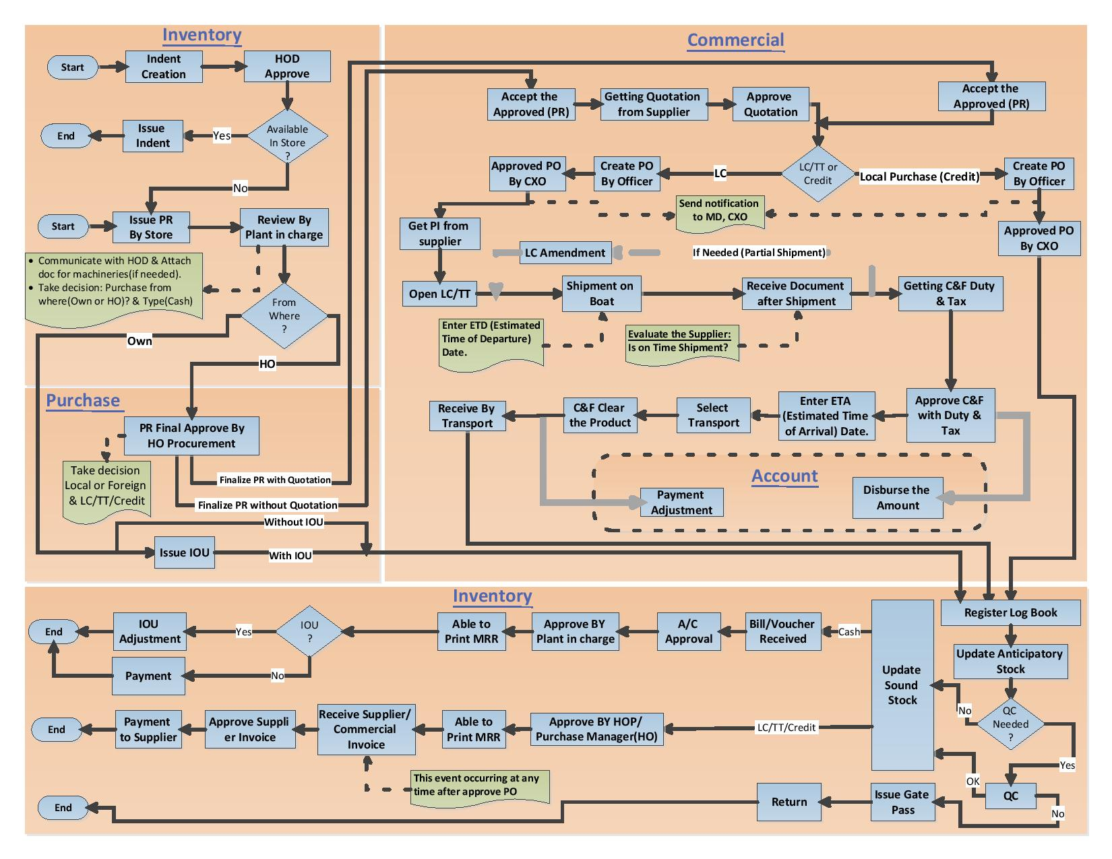

Figure: Procure to pay process flow

# 2. Purchase requisition

A purchase requisition is a formal document that is used when an employee needs to purchase or order something on behalf of their organization. This document informs the Inventory managers or Inventory user of the decision so the purchasing department can start the process of purchasing the requested products or services.

**PR Number:** System will generate auto a unique PR no after Issue. Here will first operating number then Year then unique a number.

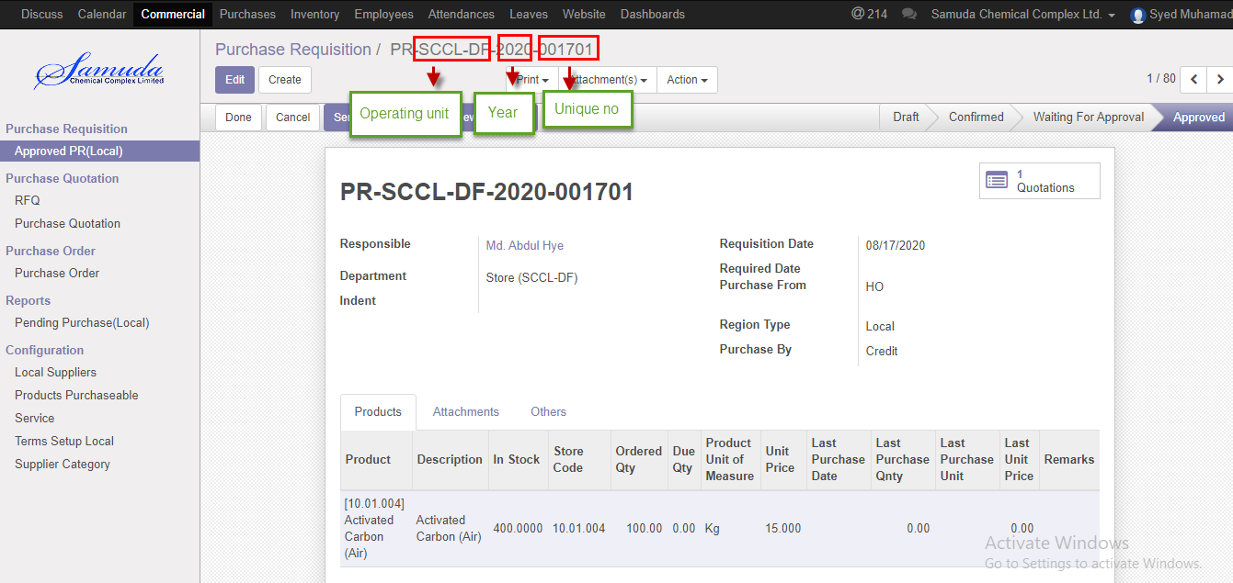

Figure: PR no

## 2.1 Approved PR (Local) View by Purchase user (Local)/Manager

Approve PR will view by procurement user.

Procurement users can View Approve PR using the menu **Commercial ‣ Purchase requisition ‣ Approved PR (Local)** and **Click**

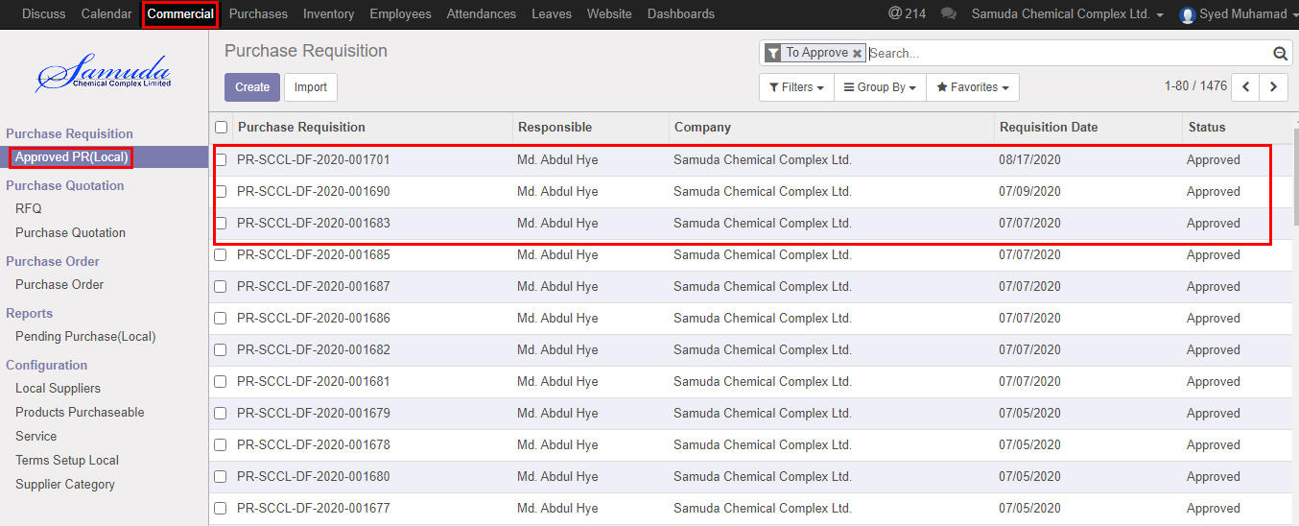

Figure: Approved PR (local) List view

## 2.2 PR Creation by Inventory user or Manager

PR will be created/Edit by Inventory user/Manager.

PR is possible for with indent and without indent

PR is possible with multiple indents if user want.PR no has system generated.

Inventory manager/user can create PR using the menu **Purchases ‣ Purchase ‣ Purchase requisition ‣ click & Confirm.**

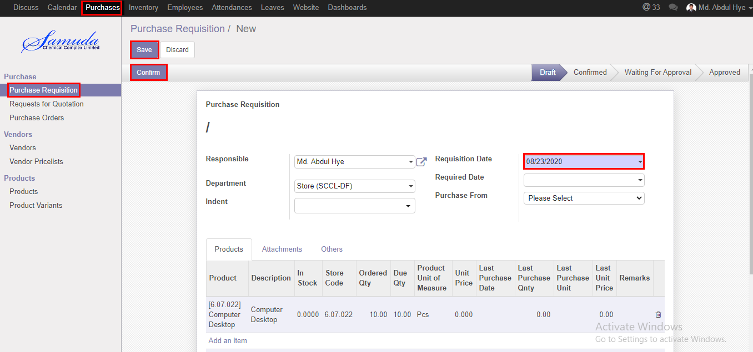

Figure: PR Creation

## 2.3 PR Validate by Plant In charge

Validate PR by click **Validate** Button. Validate by Plant in charge.

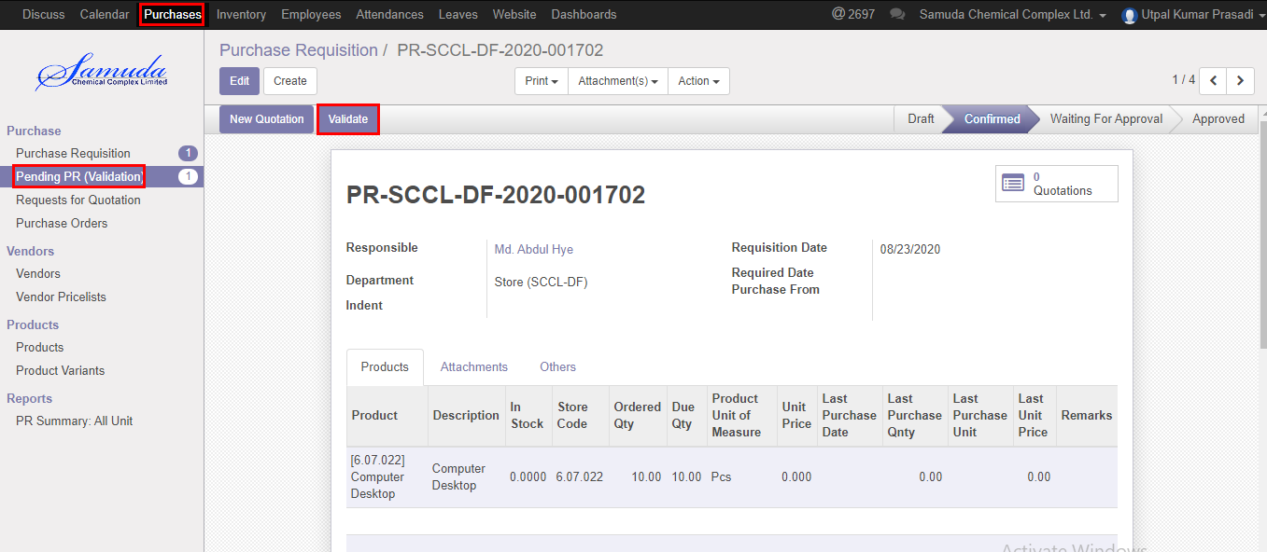

Figure: PR validate

After click Validate button will open following window then Select purchase from, Region type, Purchase By and then **save**

If select own then will go for Issue IoU and select HO then will go for HO procurement for Final approve**.**

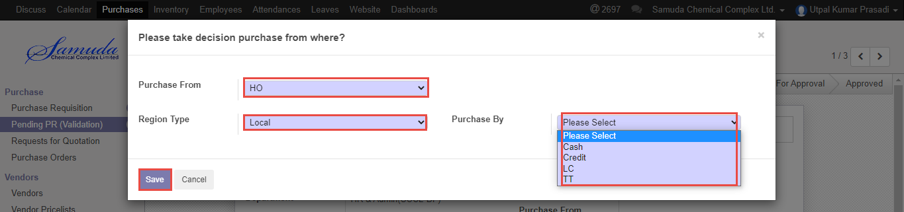

Figure: Purchase from window

## 2.4 PR approval by Head of procurement

After Validate the PR Head of Procurement will get the notification. He/she can approve to see use the menu **Purchases ‣ Purchase>>Pending PR (Approved)** Click **Approve**

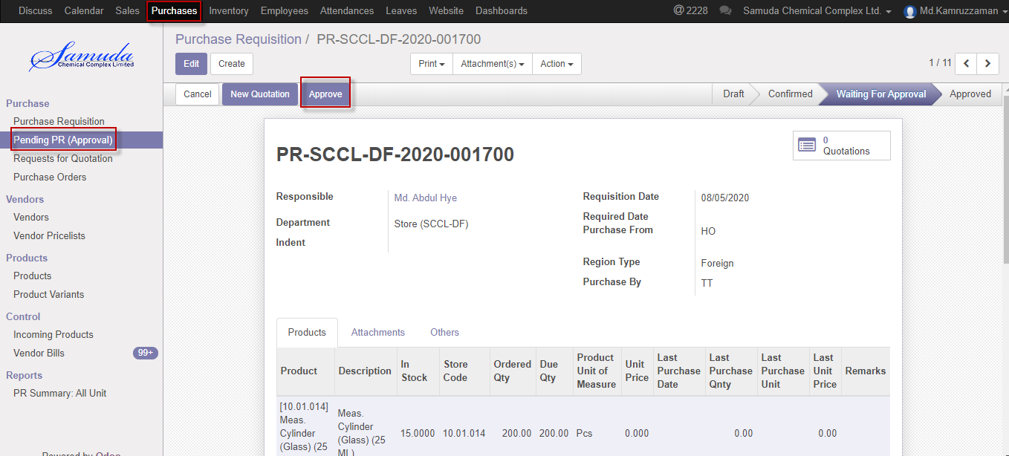

Figure: Pending PR waiting for approval

Following window will open after click **Approve** button then select region type & Purchase by

Select region type Local or Foreign and also will select Purchase by which method Cash,Credit,LC or TT. 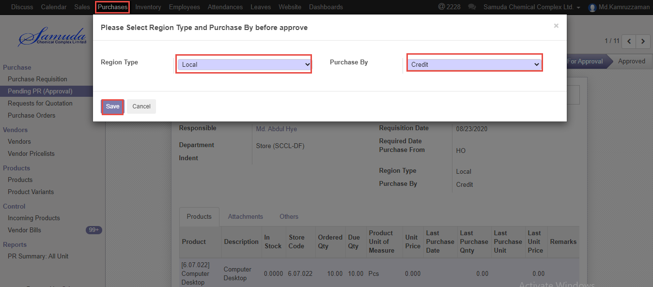

Figure: Purchase method

Following window will open after click **save** button then will ready for New Quotation .New quotation Approve by Head of procurement. 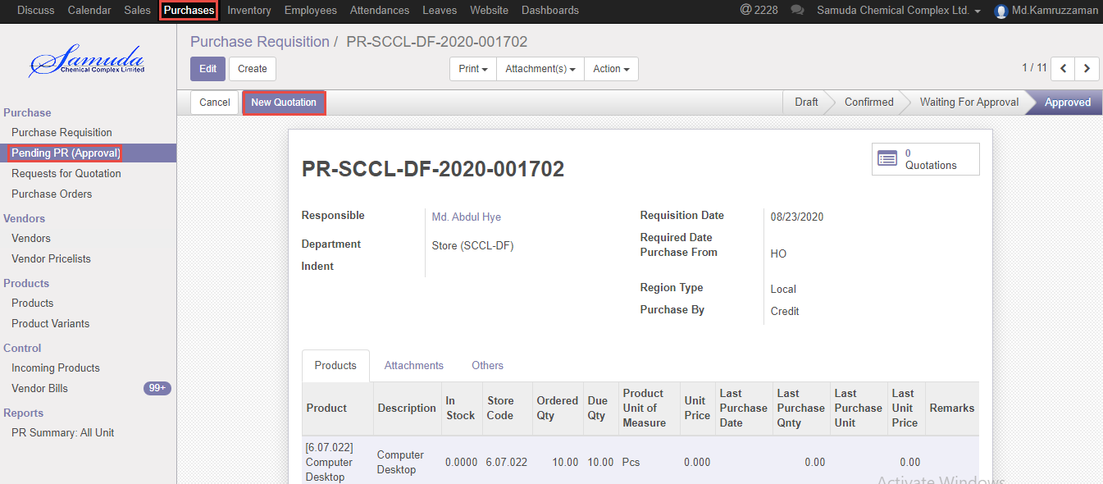

Figure: Create new quotation

Click New quotation button & Select supplier after select all info will come auto and head of procurement is capable to edit then Click **Confirm order** button. Confirmed By Head of Procurement.

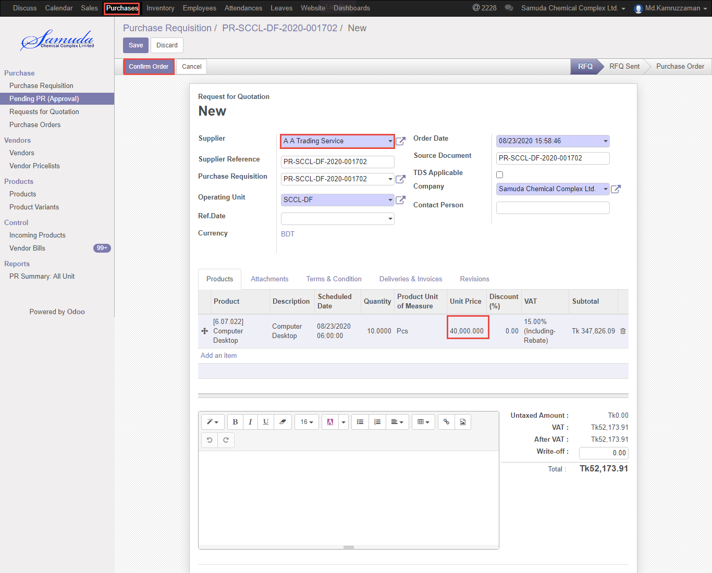

Figure: Confirm order

Following window will open after click Confirm order Button then select region type & purchase by then save then Click Purchase order button then finally Purchase order will approve.

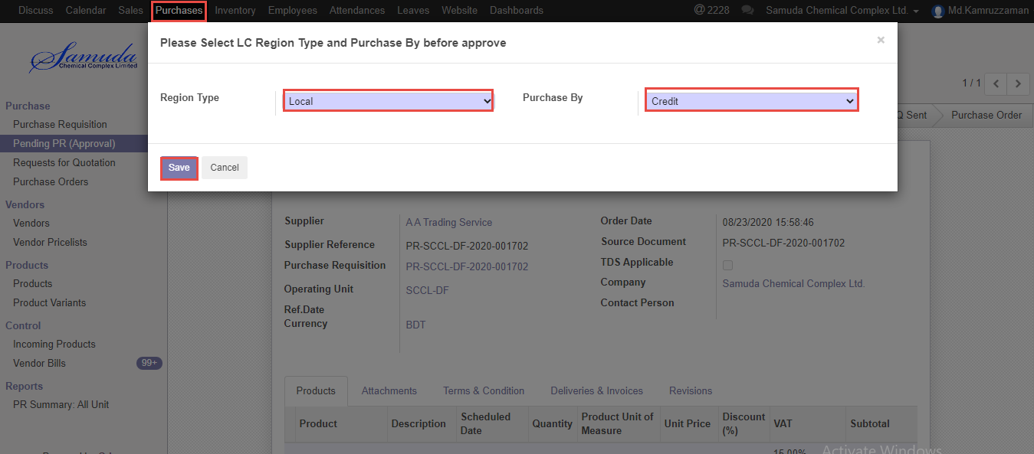

Figure: Purchase method

# 3. Send RFQ

Procurement user will get Approved PR list then He/she will create Send RFQ for Comparative bid study report. Finally will select a quotation to confirm order.

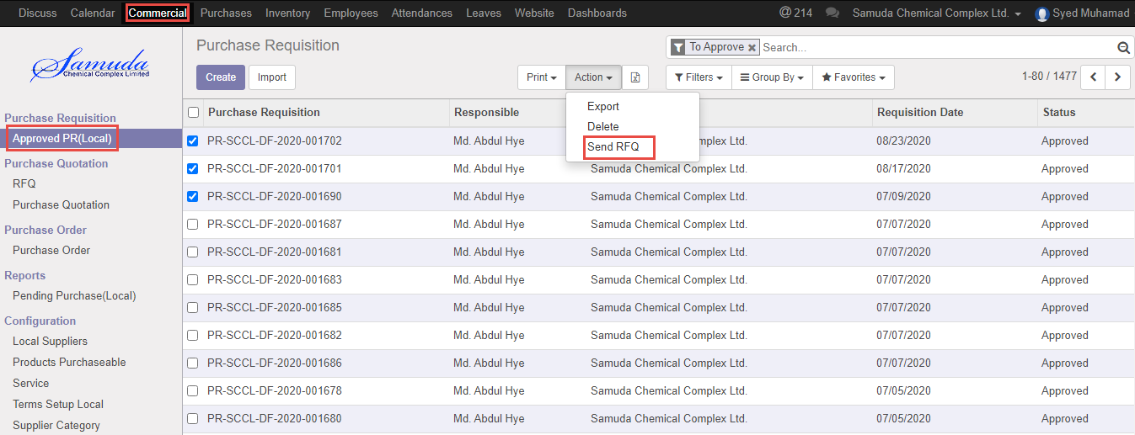

Figure: Send RFQ

## 3.1 Send RFQ create by Purchase user (Local)/Manager

Procurement users can Send RFQ using the menu **Commercial ‣ Purchase requisition ‣ Approved PR (Local) ‣ Select PR and** **Click Send RFQ**



Figure: Send RFQ

Below window will appear after click Send RFQ then click **Save**

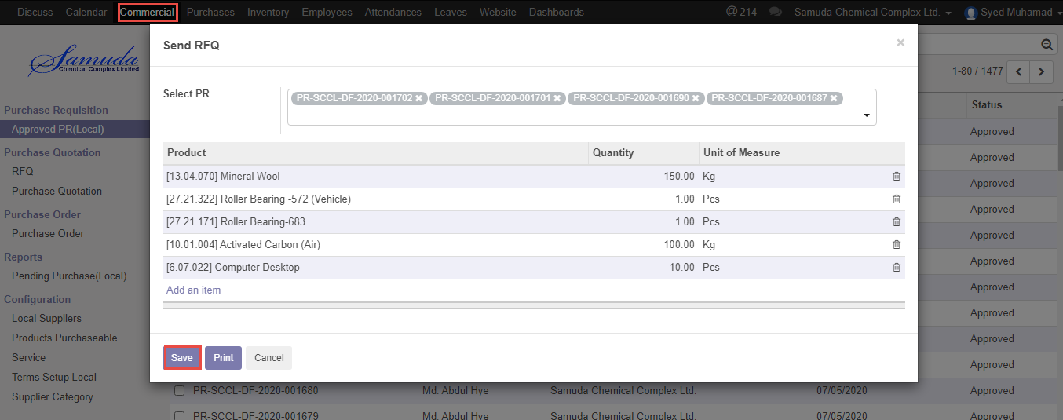

Figure: Send RFQ creation

# 4. Comparative Bid Study

Procurement user will compare Supplier unit price after Send RFQ then finally will select a supplier to Purchase product.

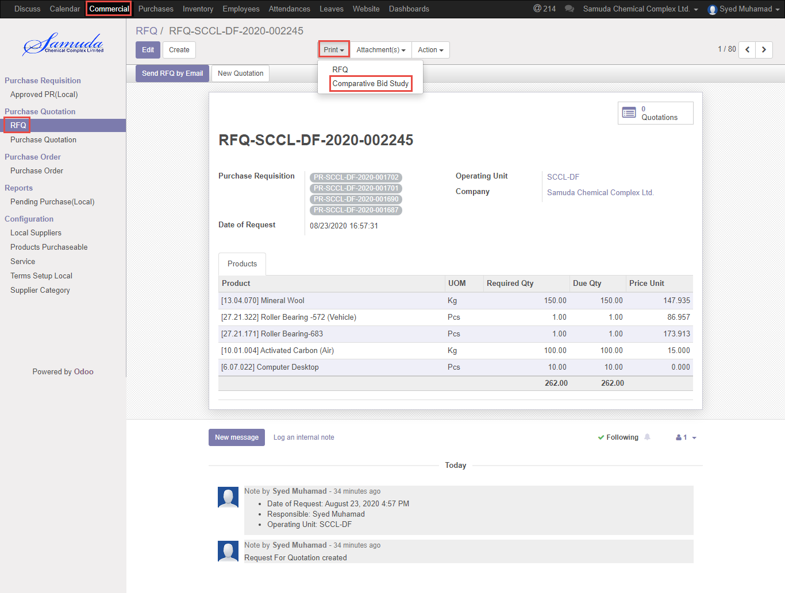

Figure: Comparative bid Study

## 4.1 Comparative bid study analysis by Purchase user (Local)/Manager

Procurement users can view Comparative bid study using the menu **Commercial ‣ Purchase quotation ‣ RFQ ‣ Print ‣** Click **Comparative bid study**



Figure: Comparative Bid Study

Comparative Bid study PDF reports.

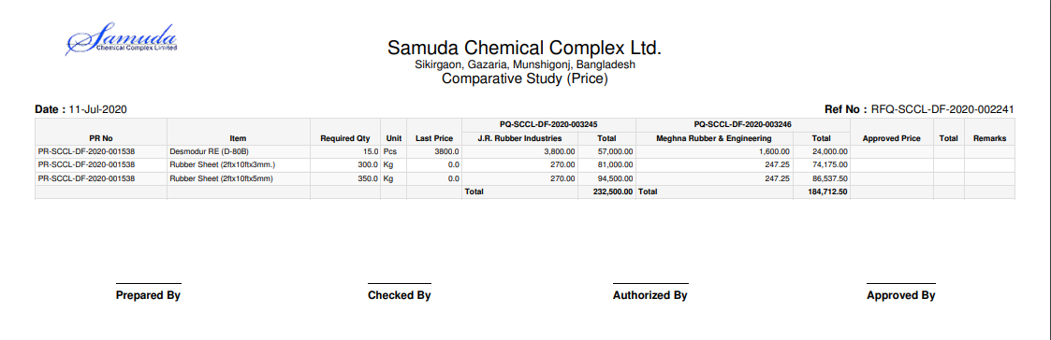

Figure: Comparative Bid Study PDF format

# 5. View Purchase quotation

Procurement user will view purchase quotation .Purchase quotation will create after completion Send RFQ.

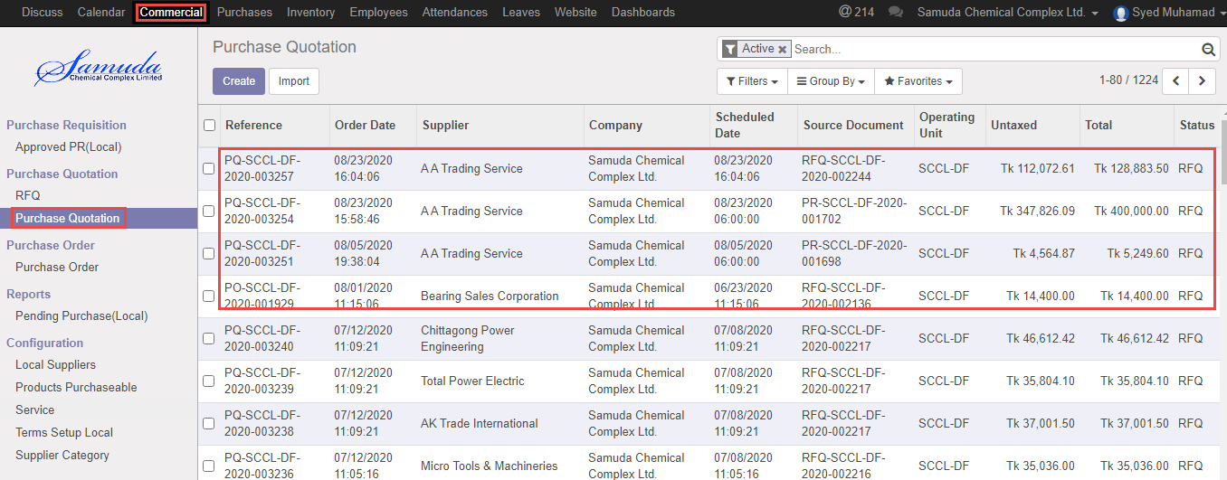

Figure: Purchase quotation list view

## 5.1 View Purchase quotation by Purchase user (Local)/Manager

Procurement users can view purchase quotation using the menu **Commercial ‣ Purchase quotation ‣ Purchase quotation ‣** Click



Figure: Purchase Quotation

# 6. Purchase order

A purchase order (PO) is a commercial document and first official offer issued by a buyer to a seller indicating types, quantities, and agreed prices for products or services. It is used to control the purchasing of products and services from external suppliers. Purchase orders can be an essential part of enterprise resource planning system orders.

Indent/requisition is a purchase order often placed through an agent under specified conditions of sale.

The issue of a purchase order does not itself form a contract. If no prior contract exists, then it is the acceptance of the order by the seller that forms a contract between the buyer and seller.

## 6.1 Confirm Purchase order by Purchase user (Local)/Manager

After compare Bid analysis user select a Purchase quotation to Confirm purchase order.

Procurement users can confirm order using the menu **Purchases ‣ Purchase ‣ Request for quotation ‣** Click

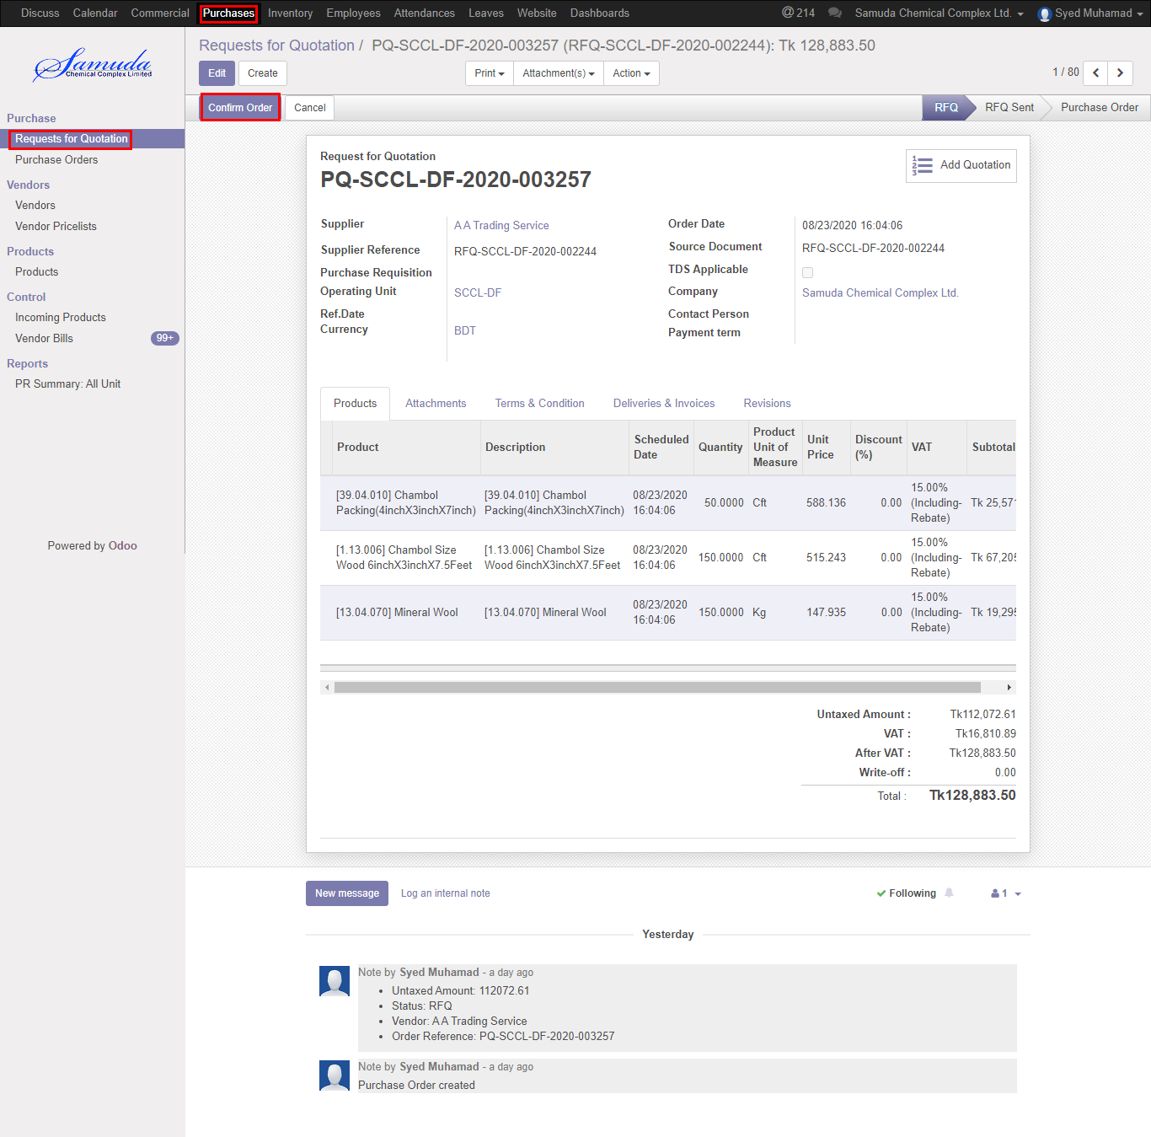

Figure: Confirm PO

Below window will open after confirm then

We need to set the following:-

**Region type**: Select region type. If select local then after approve order will view local purchase department, If select foreign then will get Foreign purchase after PO Approved.

**Purchase By:** Select purchase by.

After entering all information click **Save & Confirm**.

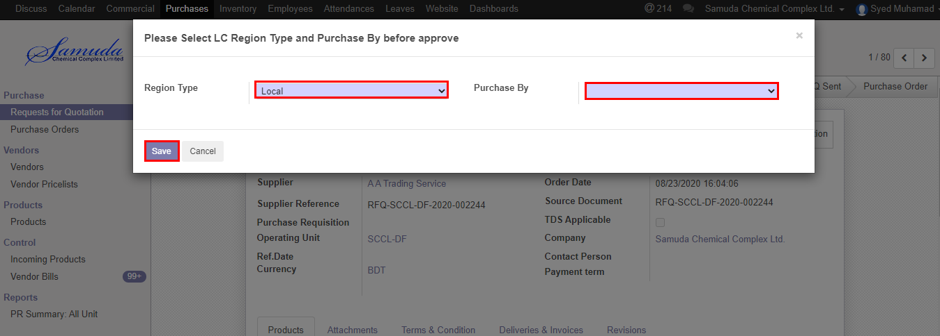

Figure: Confirm PO

# 7. View Purchase order

Procurement user will view purchase order. User also capable to search with PO number, PR number, LC number etc.

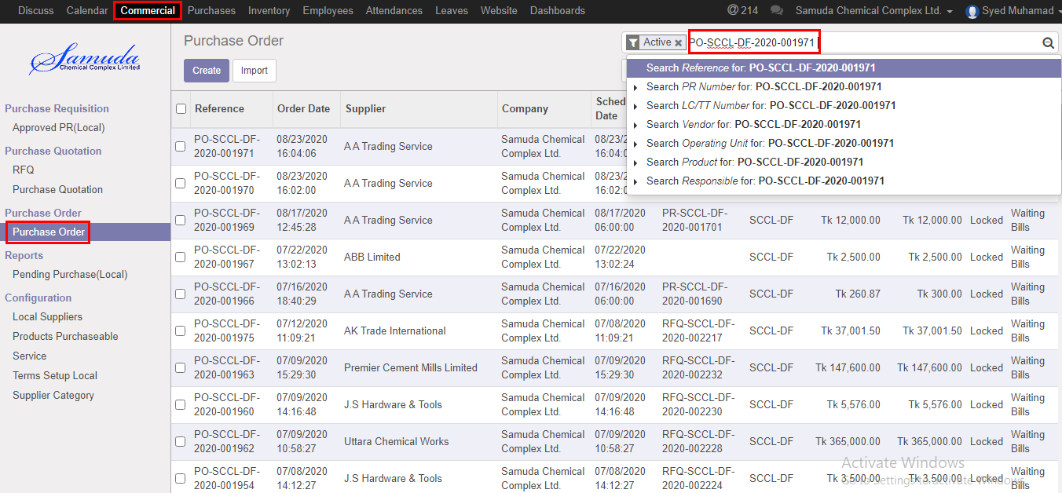

Figure: Search PO

## 7.1 View Purchase order by Purchase user (Local)/Manager

Procurement users can view purchase order using the menu **Purchases ‣ Purchase ‣ Purchase order ‣** Click

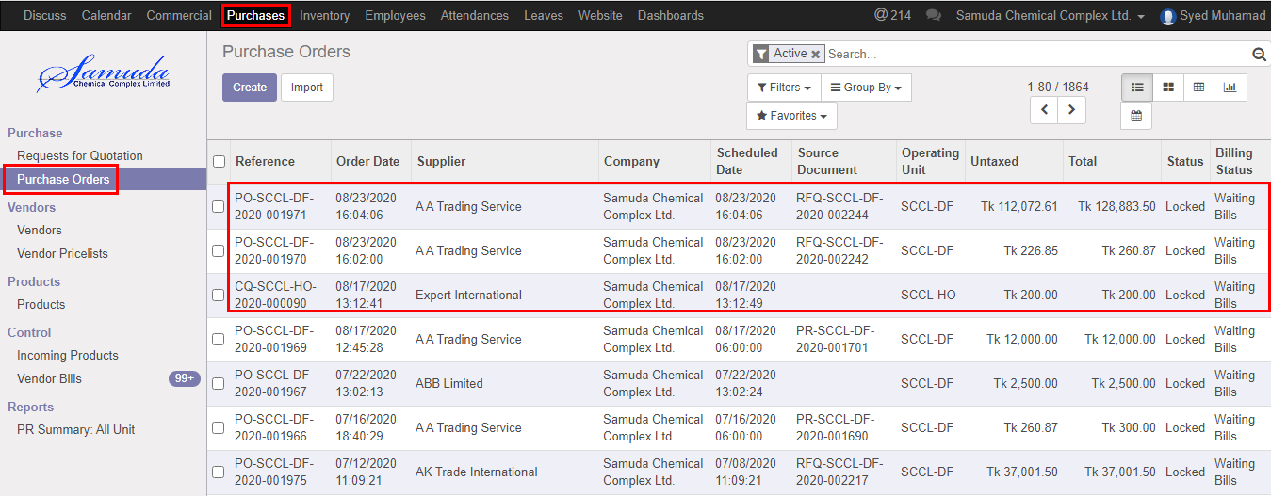

Figure: Purchase order list view

# 8. Receive goods

Receive goods are possible for below cases:

Receive goods against purchase order

Receive goods against a loan

Receive goods against a loan return

Receive goods against faulty goods (Optional)

Receive goods against LC

Receive goods against others

## 8.1 Receive goods create by Inventory Manager

Receive goods will be created/Edit by Inventory manager

Receive goods create using the menu **Inventory ‣ operations>>Receive goods** and click **Create.**

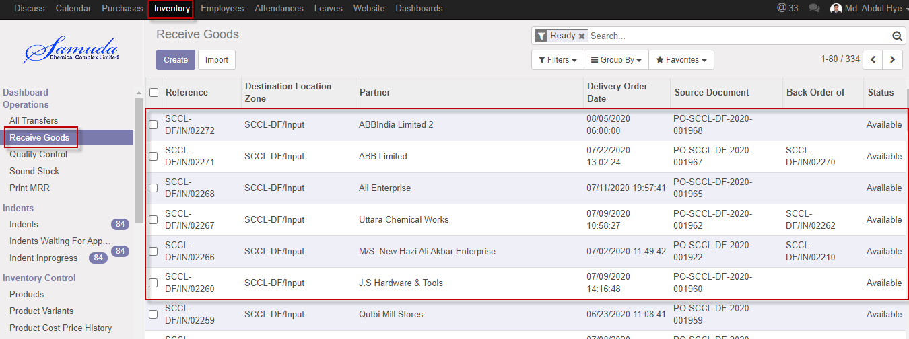

Figure: Receive goods List view

We need to set the following:-

Select goods from list item then receive click **Receive goods button**

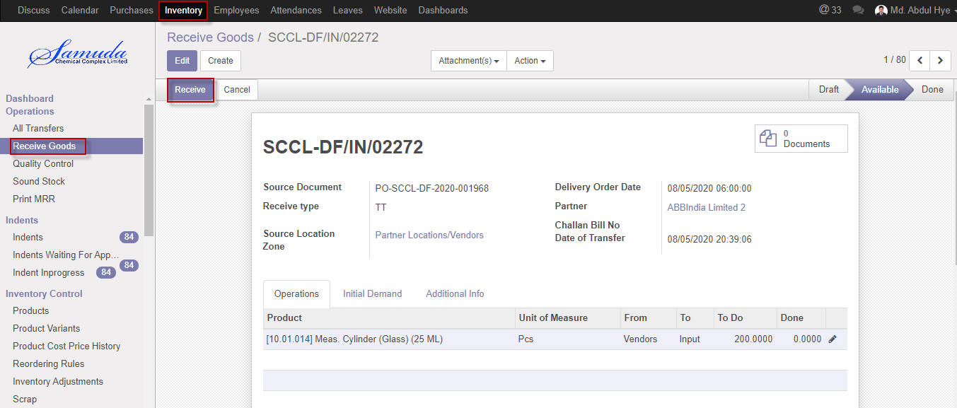

Figure: Receive goods

Cancel Receive goods with click **Cancel button.**

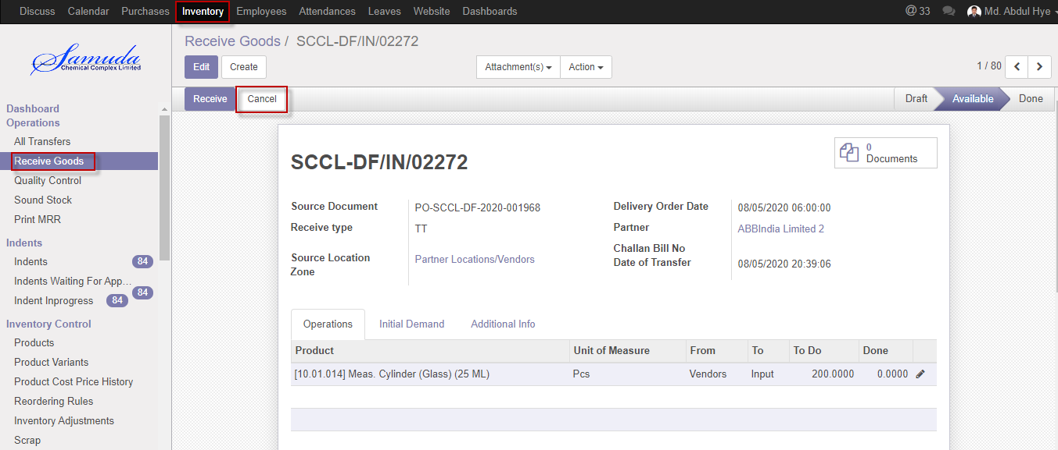

Figure: Cancel receive goods

## 8.2 Partial Receive goods creation by Inventory manager

Inventory manager will capable to partial receive goods and then will create Backorder.

Inventory manager can create Partial Issue receive goods using the menu **Inventory ‣ Operation** >>**Receive goods>>** click **Receive goods** Button**.**

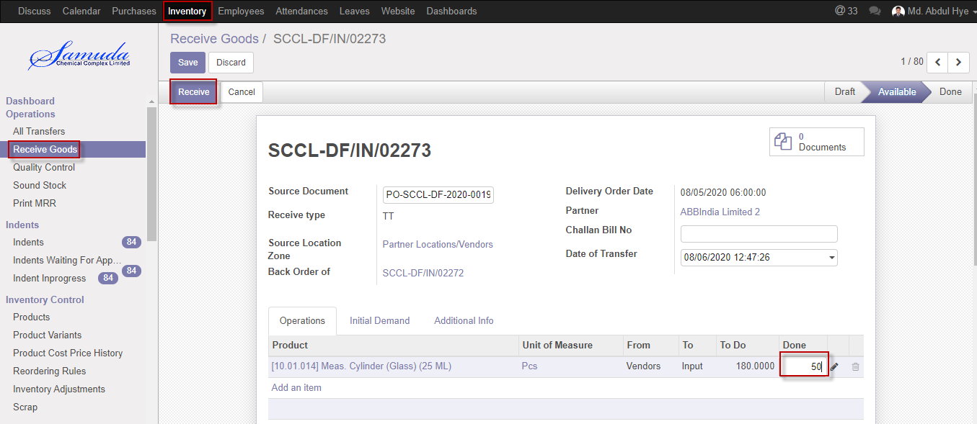

Figure: Partial receive goods

After click Receive button will open Backorder window then Click **Backorder** buttonthen finally Backorder will go create and receive will done.

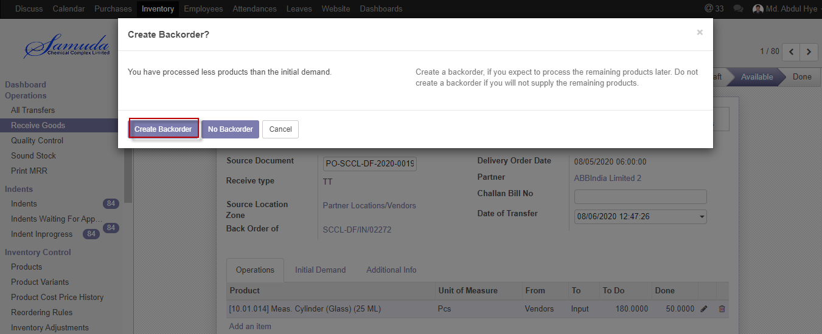

Figure: Create Backorder

# 9. Quality Control

Store keeper receives goods which was sent by supplier. QC Authority checks the quality and quantity of goods as per Order. According to QC result they take necessary decision.

If goods are in good quality and exact quantity then QC accept the goods and update the stock of the goods.

If goods are not acceptable and not in exact quantity/quality, QC authority returns the rejected goods to Store Keeper for receive return to Supplier.

## 9.1 Quality Control create by Inventory user/Inventory Manager

Quality control will be Validate/Edit by Inventory manager

Quality control validate using the menu **Inventory ‣ operations>>Quality Control** and click **Validate.**

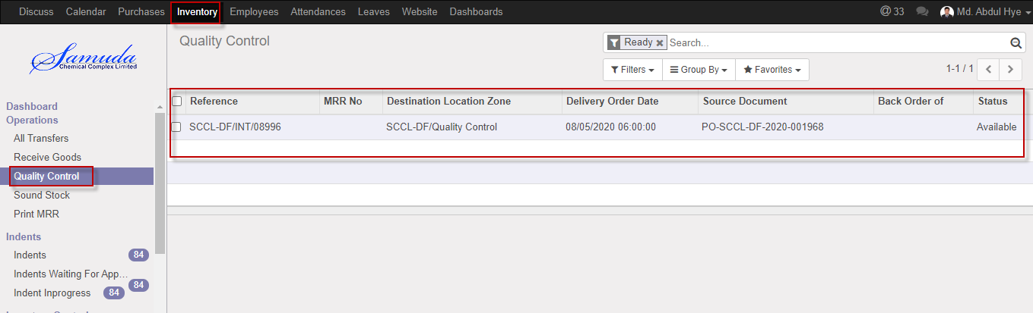

Figure: Quality control List view

We need to set the following:-

**Validate**: Click Validate button.

Quality control validate will done after click the validate button

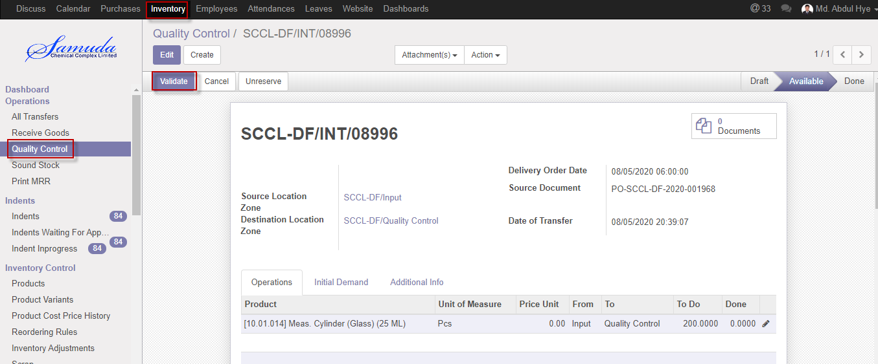

Figure: Quality control validate

Cancel Quality control with click **Cancel button.**

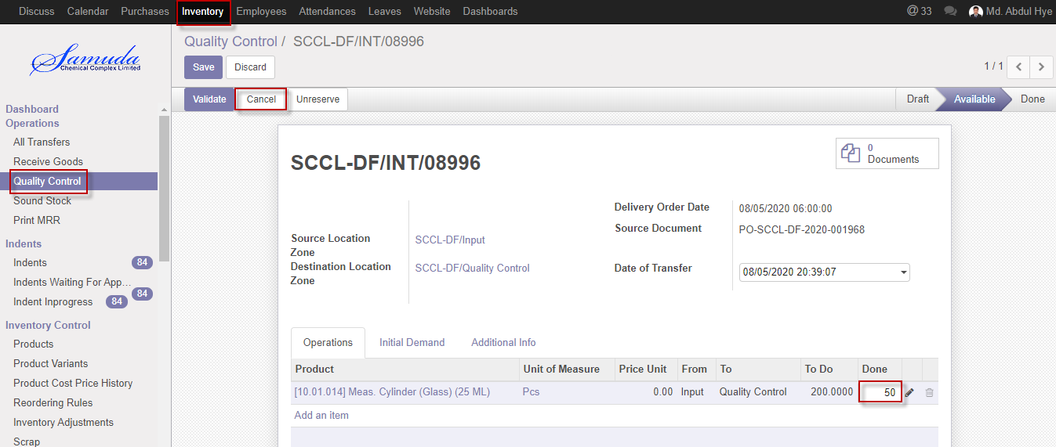

Figure: Cancel Quality control

## 

## 9.2 Partial Quality control creation by Inventory manager

Inventory manager will capable to partial quality control and then will create Backorder.

Inventory manager can create Partial quality control using the menu **Inventory ‣ Operation** >>**Quality control>>** click **Validate** Button**.**

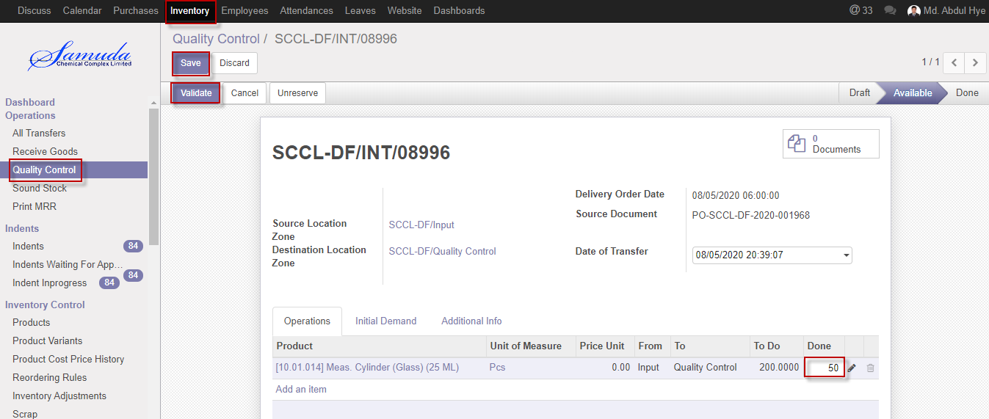

Figure: Partial QC

After click Validate button will open Backorder window then Click **Backorder** buttonthen finally Backorder will go create and QC will done.

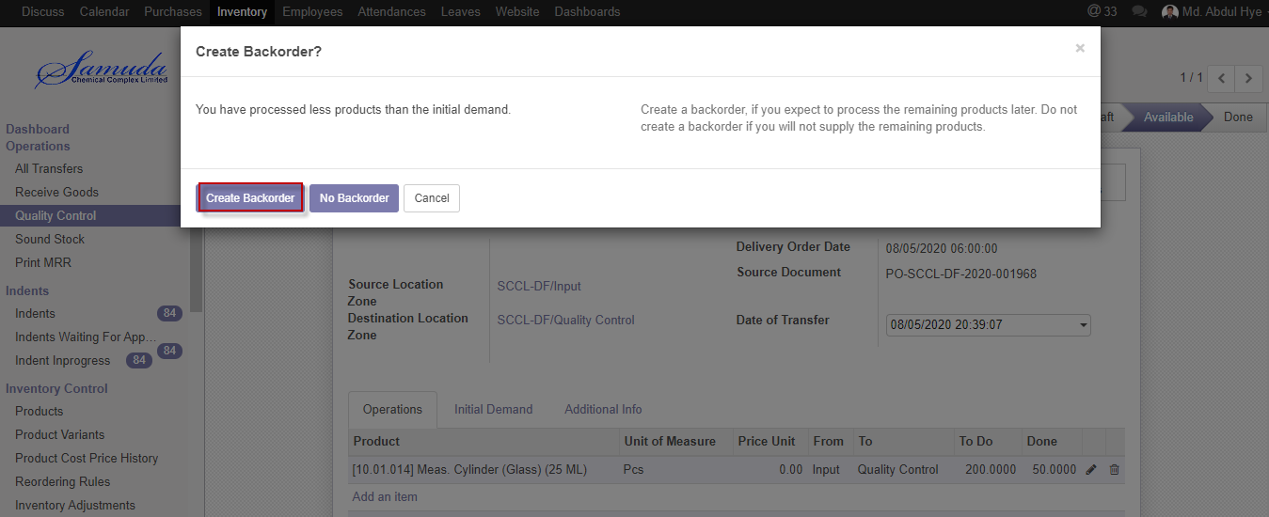

Figure: Create Backorder

# 10. Sound stock

Data will come in sound stock after Quality received. Main stock will be updated after sound stock received.

## 10.1 Sound stock Update by Inventory Manager

Sound stock will be Updated/Edit by Inventory manager

Sound stock updated using the menu **Inventory ‣ operations>>Sound stock** and click **Validate.**

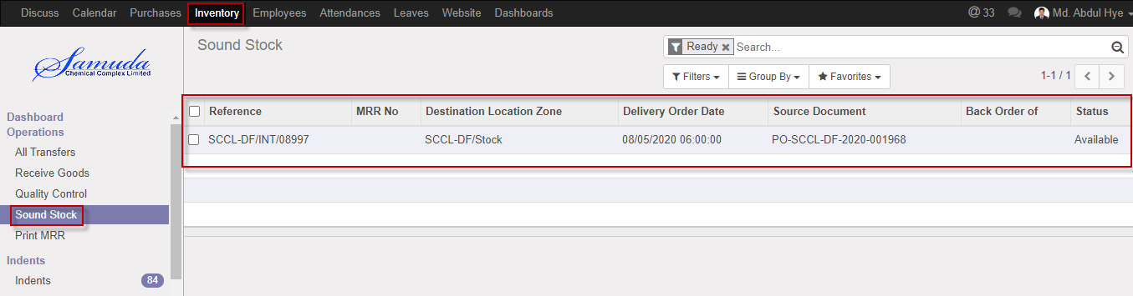

Figure: Sound stock List view

We need to set the following:-

**Validate**: Click Validate button.

Sound Stock validate will done after click the validate button

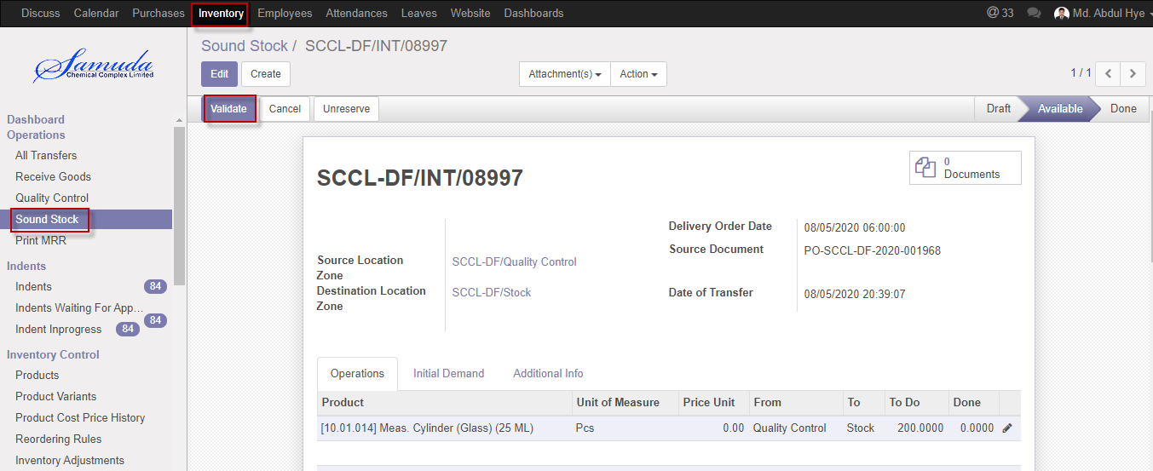

Figure: Validate sound stock

Cancel Sound stock with click **Cancel button.**

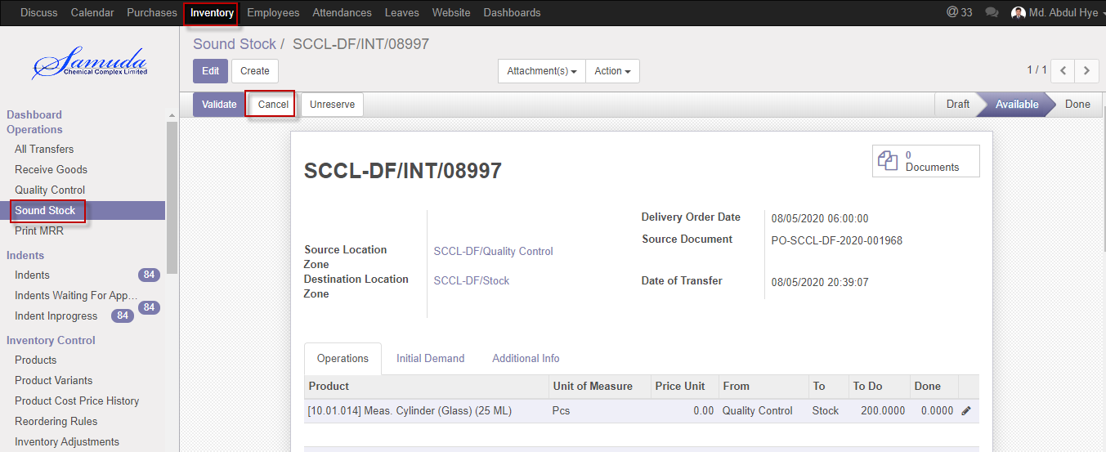

Figure: Cancel Sound stock

## 10.2 Partial Sound stock creation by Inventory manager

Inventory manager will capable to partial Sound stock and then will create Backorder.

Inventory manager can create Partial Sound stock using the menu **Inventory ‣ Operation** >>**Sound stock>>** click **Validate** Button**.**

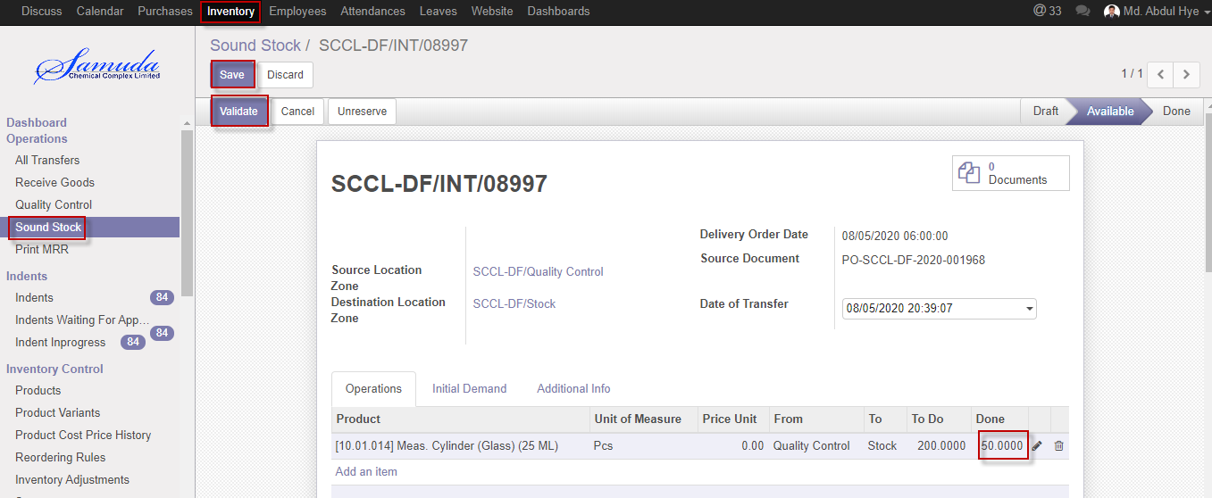

Figure: Partial Sound stock

After click Validate button will open Backorder window then Click **Backorder** buttonthen finally Backorder will go create and Sound stock will update.

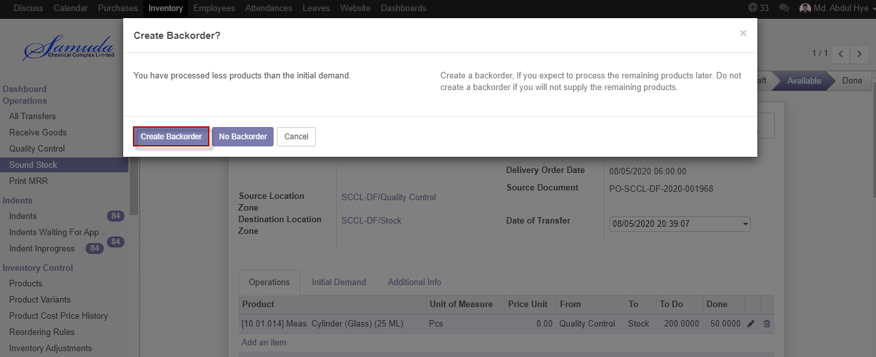

Figure: Create Backorder

# 11. Vendor Bills

Vendor bill payment will happen two ways one is purchase order against & other is Supplier against. Vendor bill will create/validate by procurement user. Finally accounts manager will approve vendor bill.

## 11.1 Vendor bill payment PO against initiate by Procurement user

Vendor bill will be Initiate/Edit by procurement user

Vendor bill creation using the menu **Purchases ‣ Purchase ‣ Purchase order** and click **Vendor bill.**

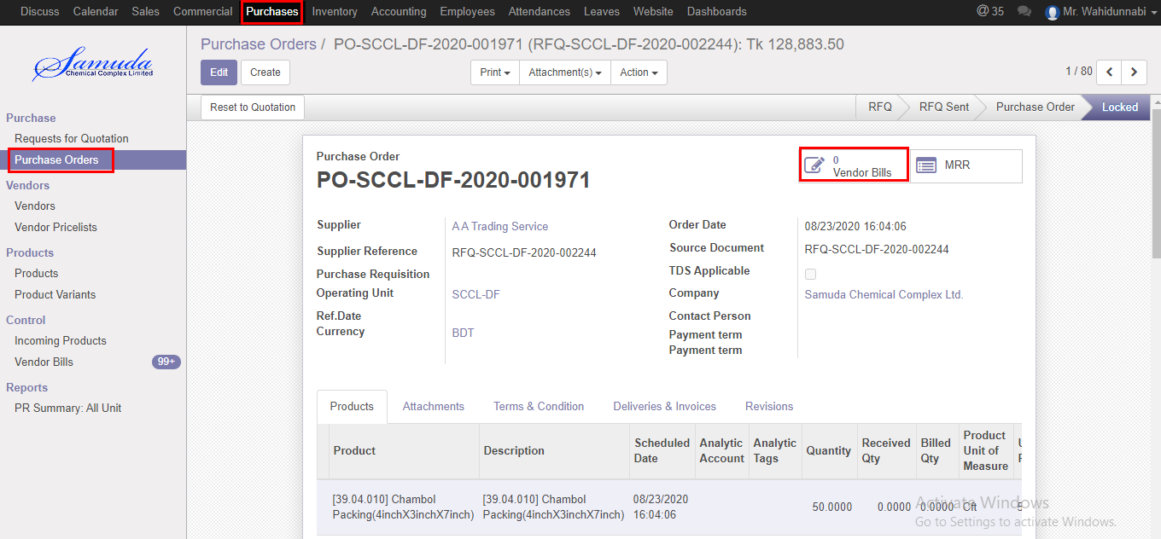

Figure: Vendor bills

We need to set the following:-

**Bill date**: Select bill date.

**Vat**: Enter vat info.

**Product Qty**: Enter product qty.

After entering all information click **Save & Confirm**.

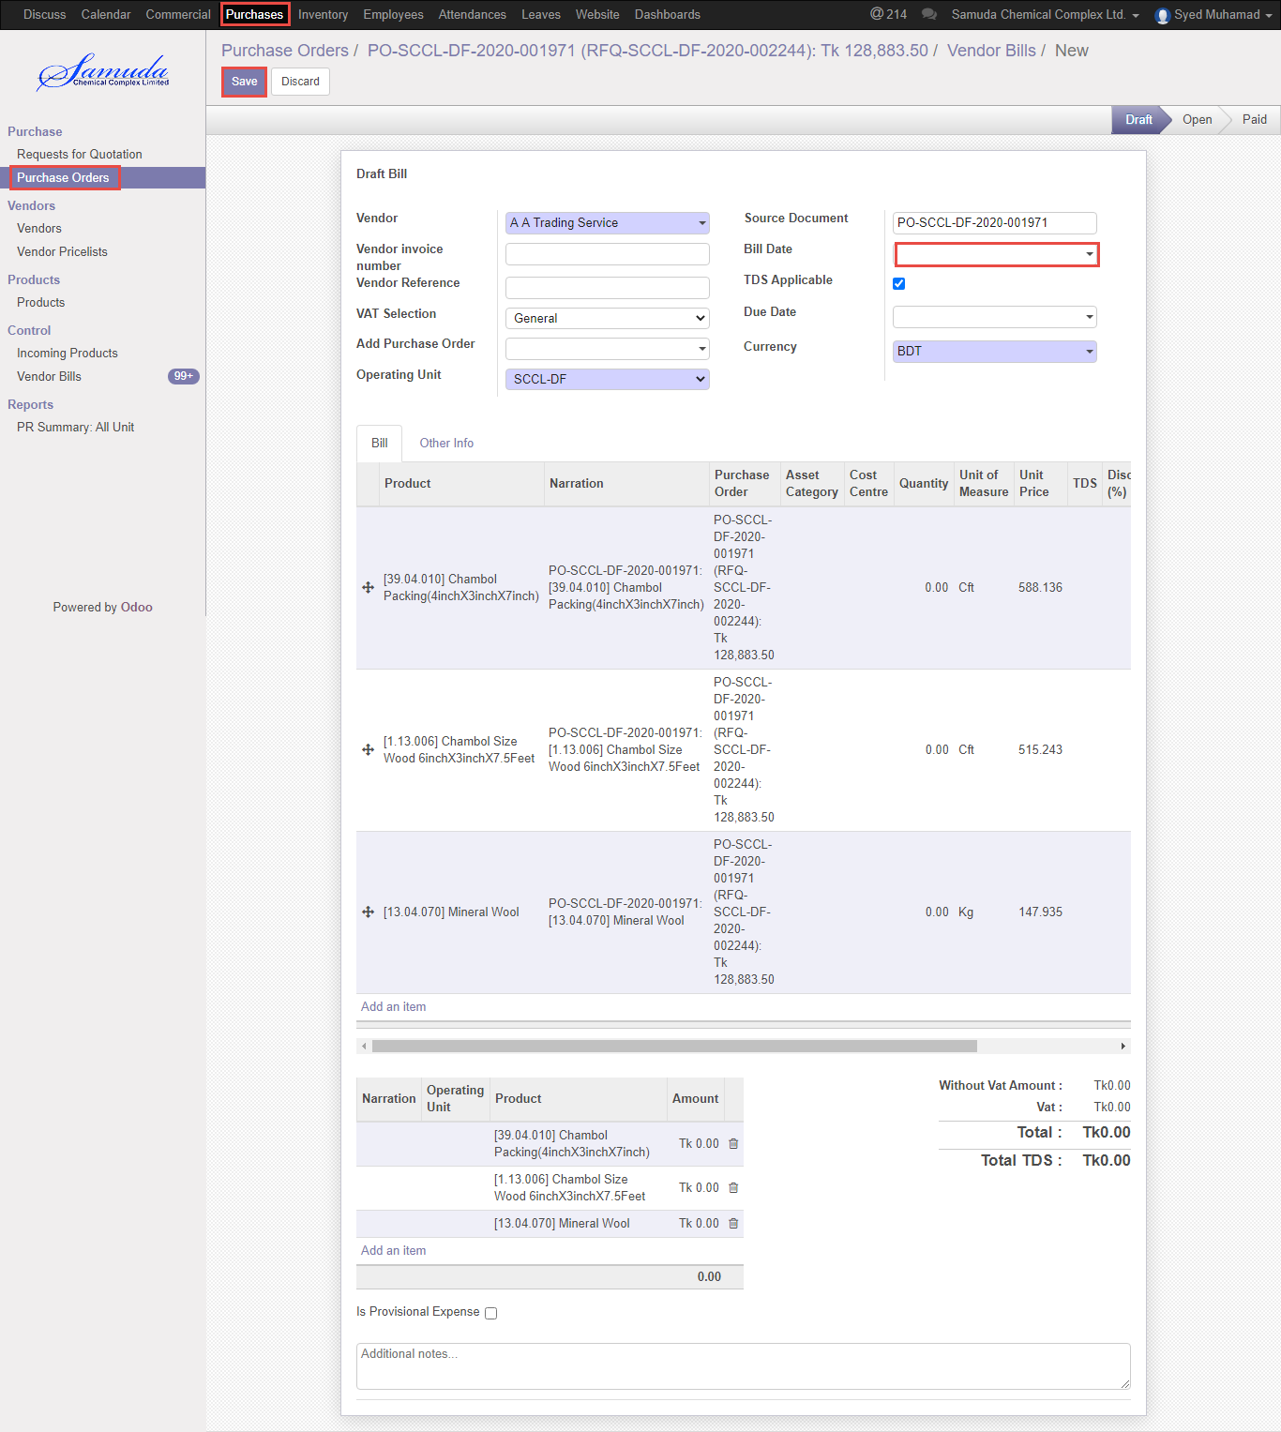

Figure: Vendor bill creation

## 11.2 Vendor bill payment validate by Accounts Executive/Manager

Vendor bill validate will be created/Edit by Accounts user/manager

Vendor bill validate using the menu **Accounting ‣ Purchases ‣ Vendor bills** and click **Validate** button

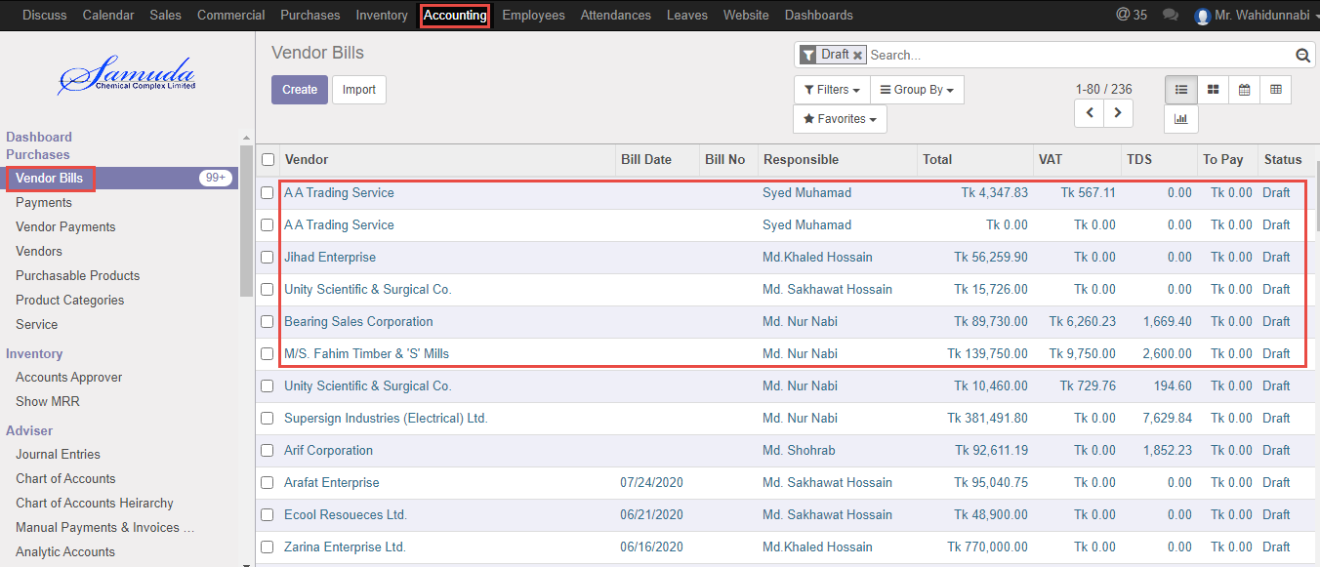

Figure: Vendor bills list view

Validate vendor bill to click **Validate button**.

After validate Vendor Accounts payable will increase.

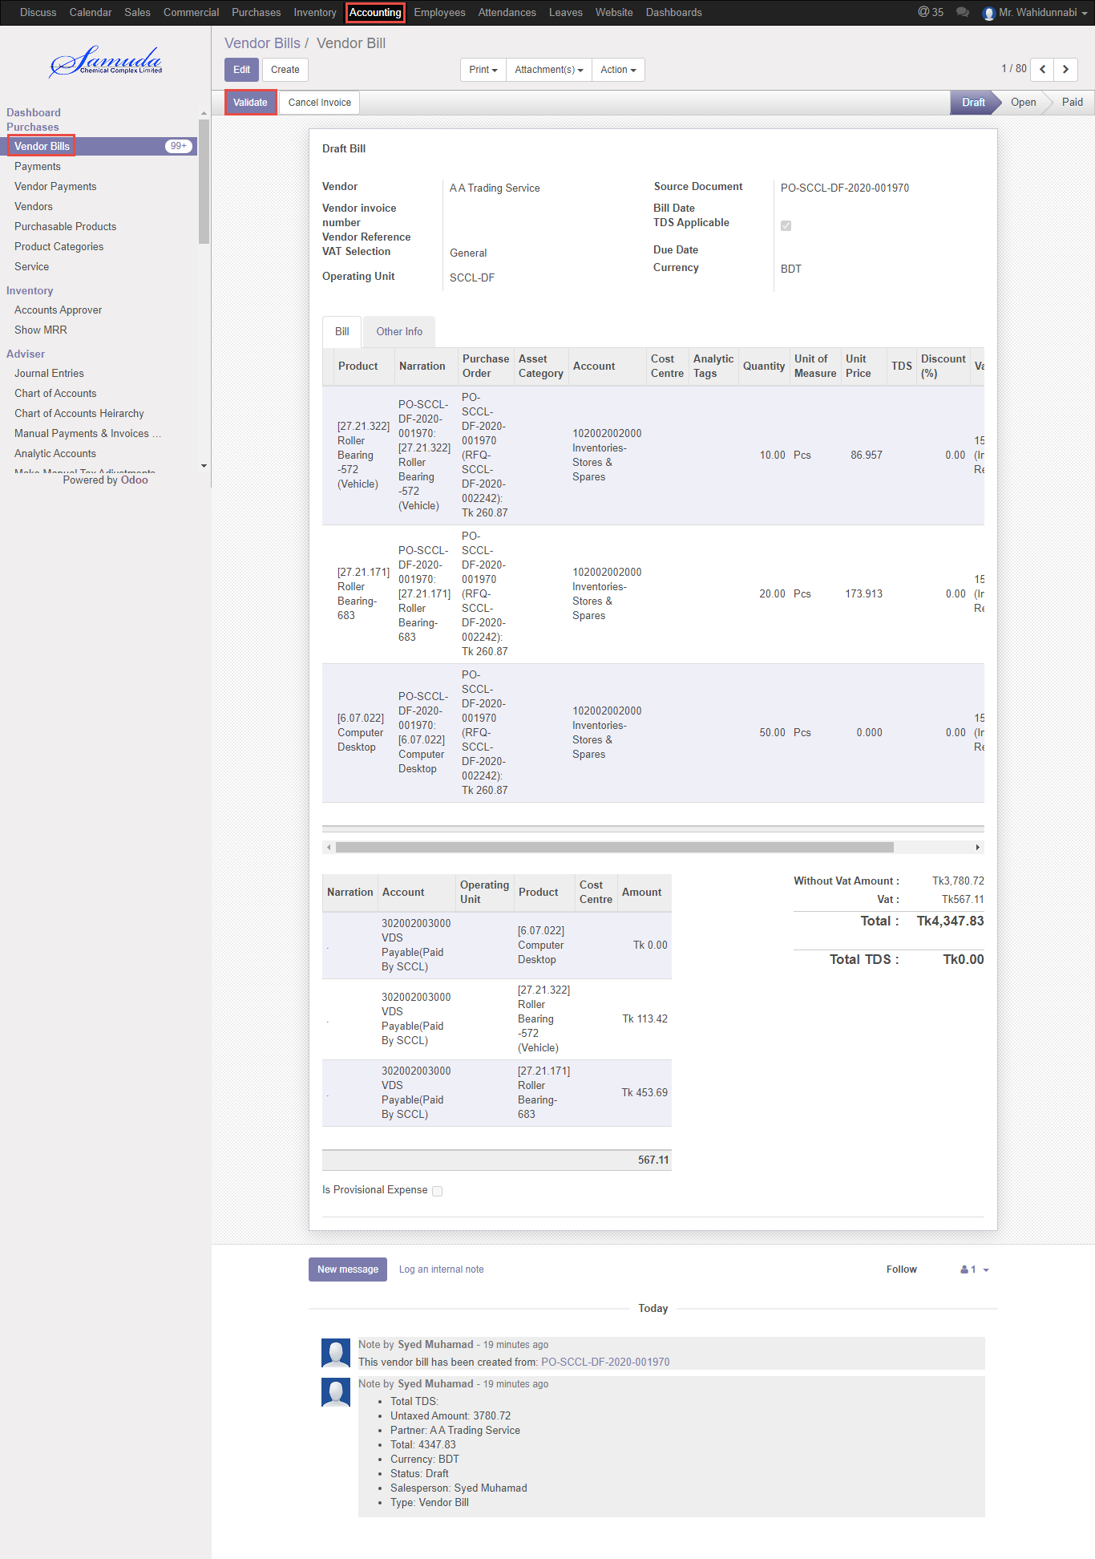

Figure: Vendor bill validate

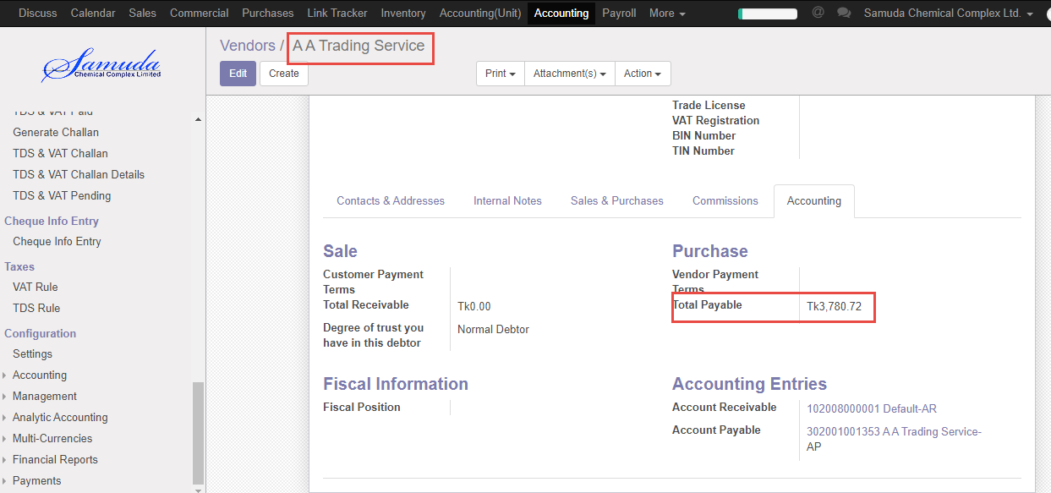

Figure: increase vendor accounts Payable

Cancel invoice to click **Cancel button**.

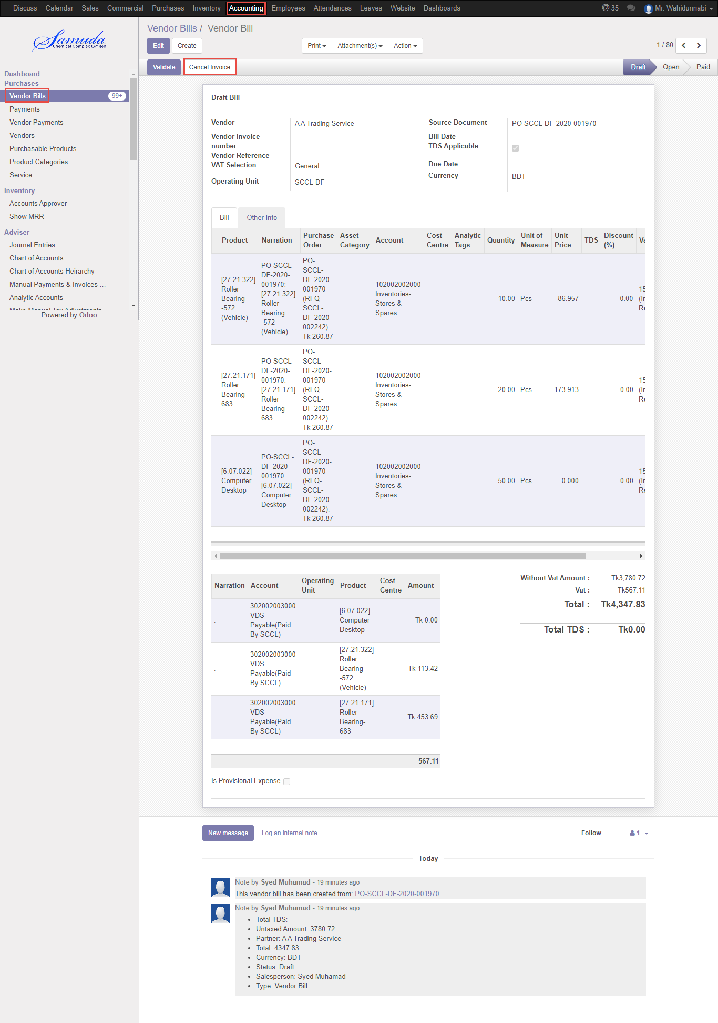Figure: Cancel invoice

## 11.3 Vendor bill register payment by Accounts Executive/Manager

Vendor bill register payment will be created by Accounts user/manager

Vendor bill register payment using the menu **Accounting ‣ Purchases ‣ Vendor bills** and click **Register payment** button

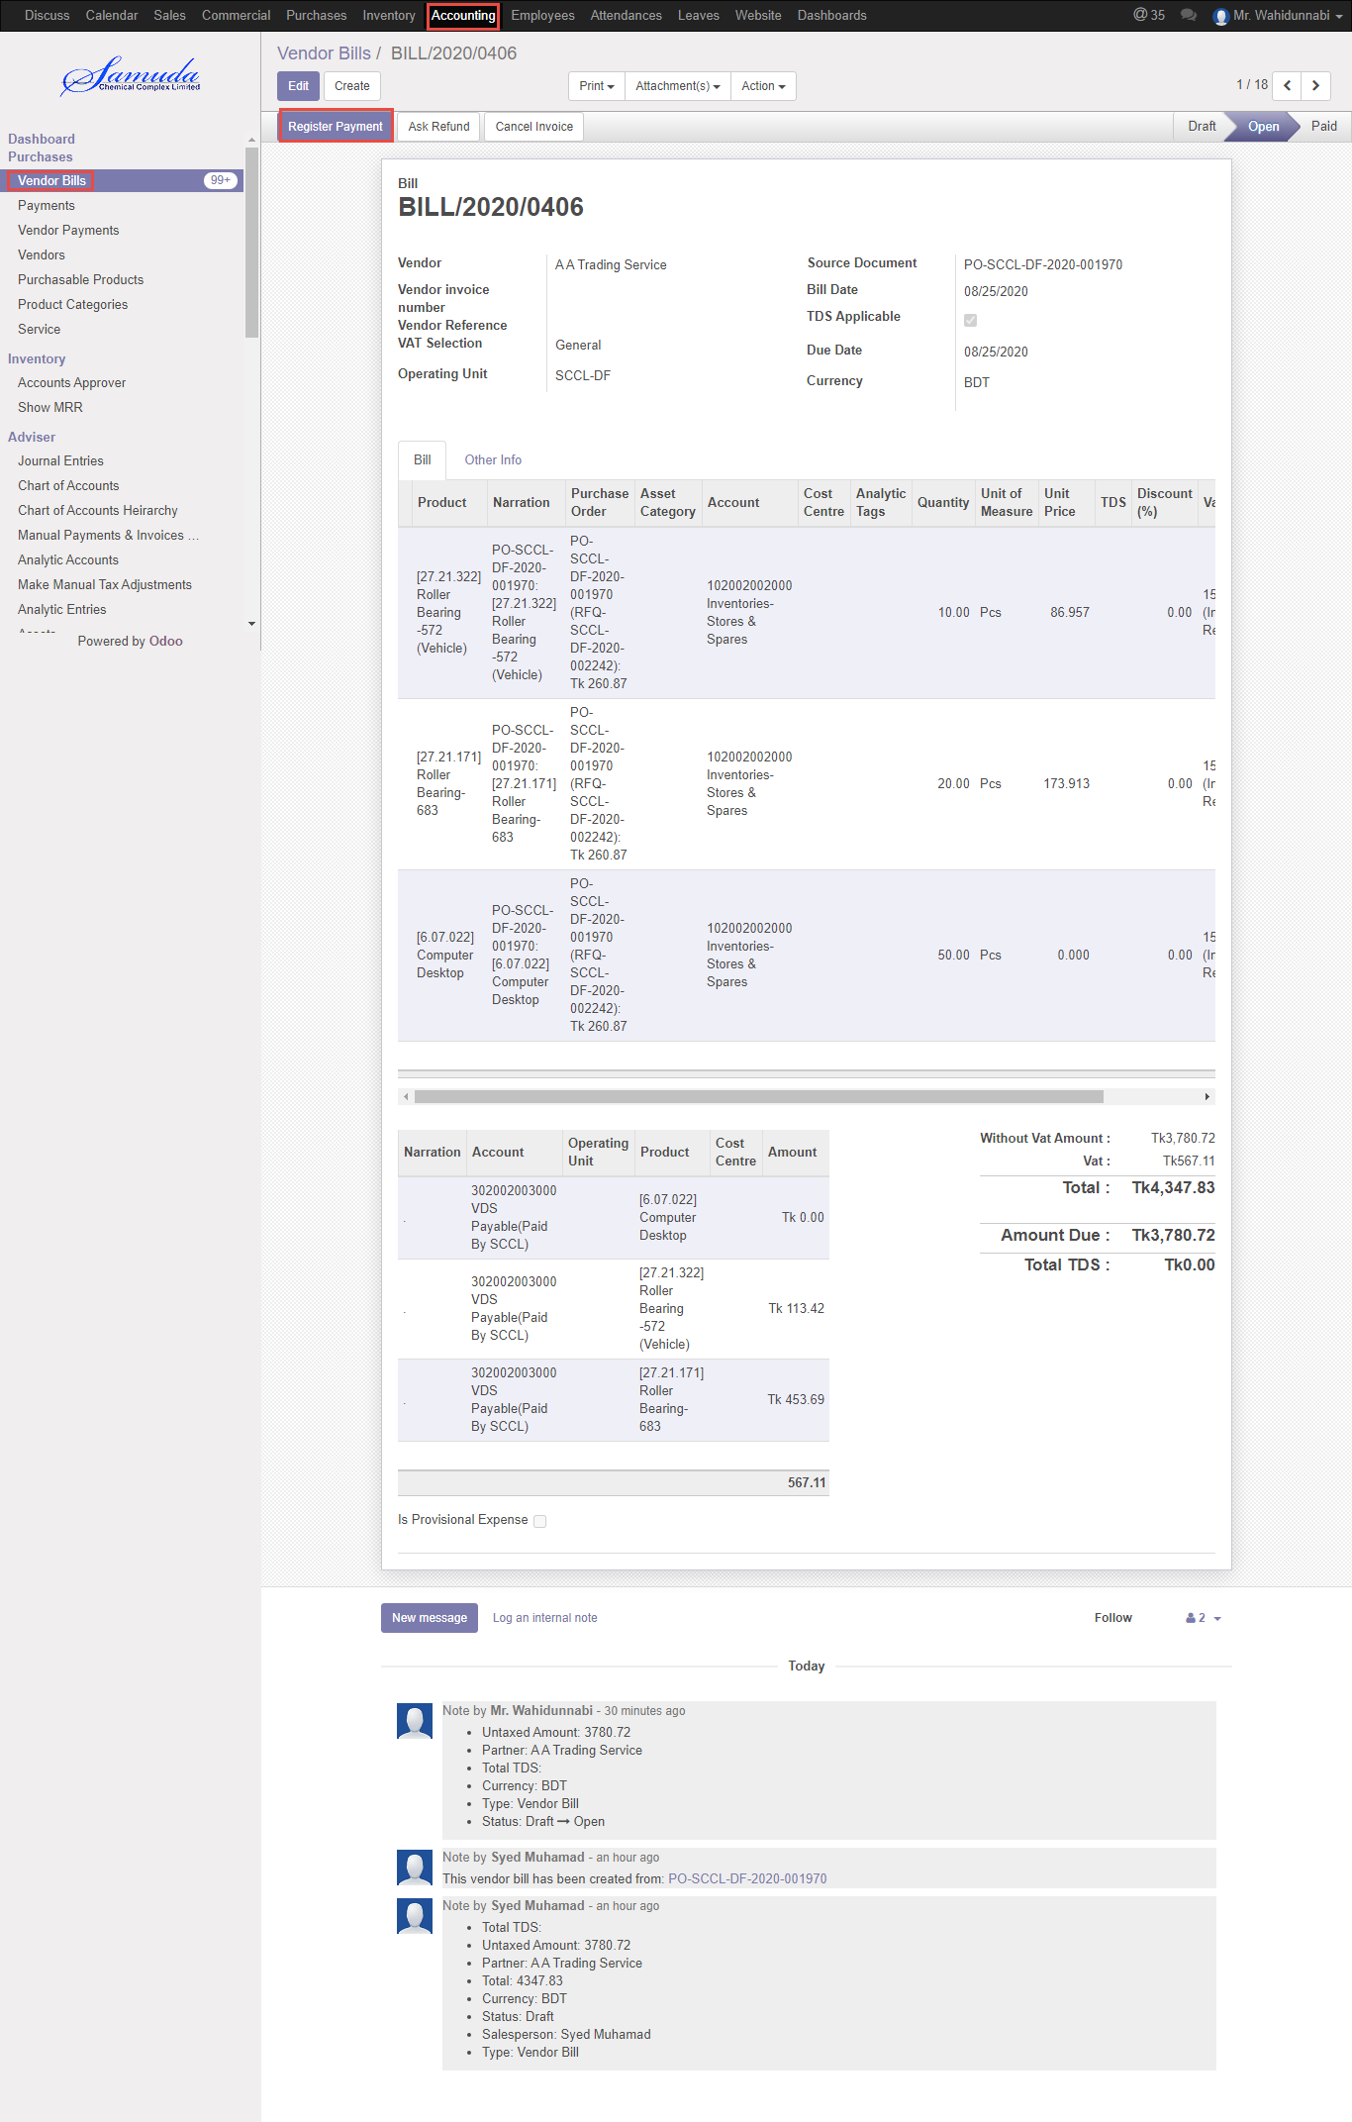

Figure: Vendor bills register payment

We need to set the following:-

**Bank Name/Journal**: Select a Bank name/journal

**Payment Date:** Select payment date.

**Payment amount:** Enter payment amount.

After entering all information click **Validate**.

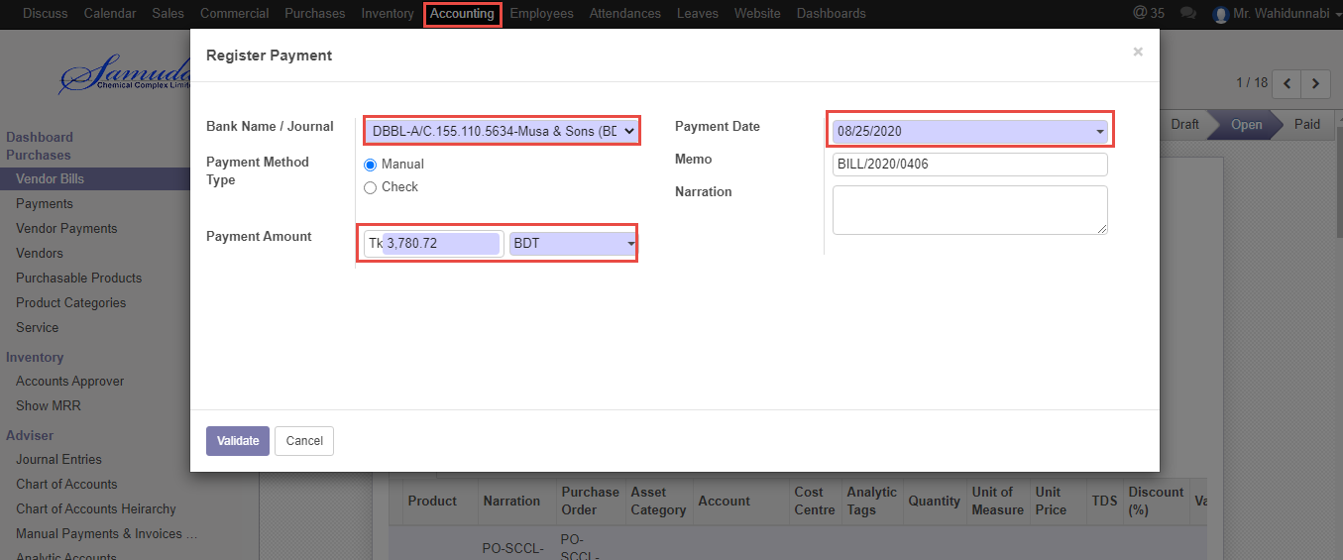

Figure: Register payment Bank journal window

After Register payment validate Vendor Accounts payable will Decrease.

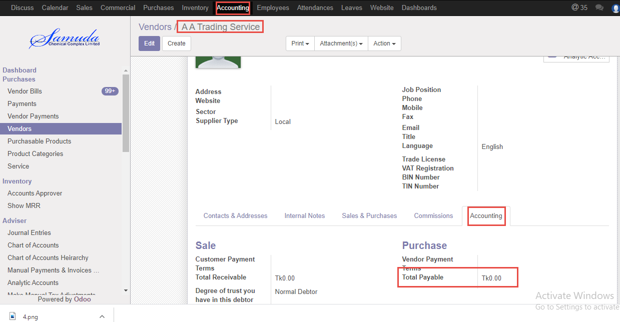

Figure: Decrease vendor accounts Payable

## 11.4 Vendor bill payment Vendor against initiate by accounts user/Manager

Vendor bill will be Initiate/Edit by Accounts user/Manager

Vendor bill creation using the menu **accounting ‣ Purchases ‣ Vendor bills** and click **Create.**

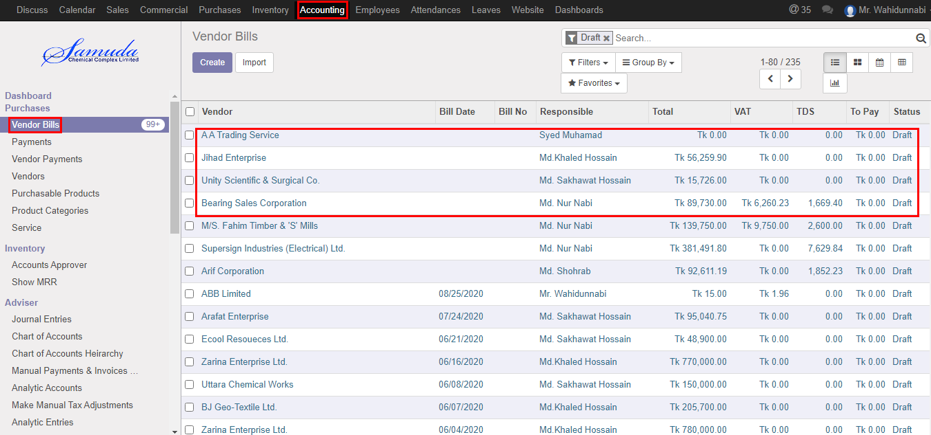

Figure: Vendor bills list view

We need to set the following:-

**Vendor:** Select a vendor.

**Bill date**: Select bill date.

**Vendor reference:** Enter vendor reference.

**Vat selection**: Select vat selection.

**Add purchase order**: Select purchase order.

**Product:** Select product info.

After entering all information click **Save & Validate**.

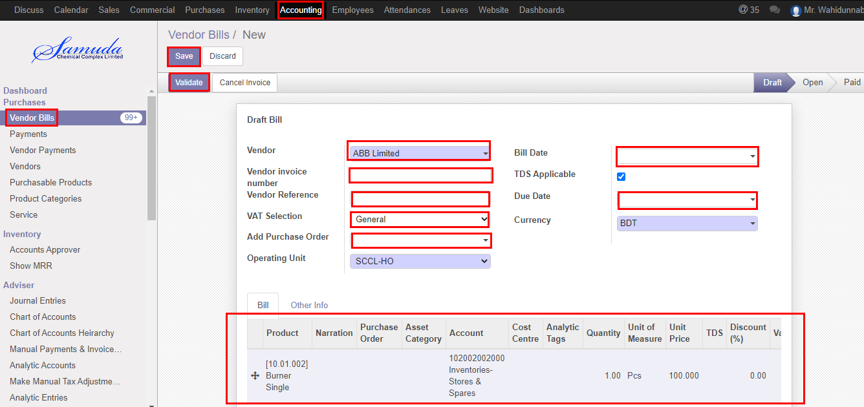

Figure: Vendor bill creation

After validate Vendor Accounts payable will increase.



Figure: increase vendor accounts Payable

Cancel invoice to click **Cancel button**.

Figure: Cancel invoice

## 11.5 Vendor bill register payment by Accounts Executive/Manager

Vendor bill register payment will be created by Accounts user/manager

Vendor bill register payment using the menu **Accounting ‣ Purchases ‣ Vendor bills** and click **Register payment** button



Figure: Vendor bills register payment

We need to set the following:-

**Bank Name/Journal**: Select a Bank name/journal

**Payment Date:** Select payment date.

**Payment amount:** Enter payment amount.

After entering all information click **Validate**.



Figure: Register payment Bank journal window

After Register payment validate Vendor Accounts payable will Decrease.



Figure: Decrease vendor accounts Payable

# 12. Reports

## 12.1 Purchase Requisition Summary Report view by Procurement user/Manager

To see the Purchase Requisition Summary Report use the menu **Purchase ‣ Reports ‣ Purchase requisition summary reports**

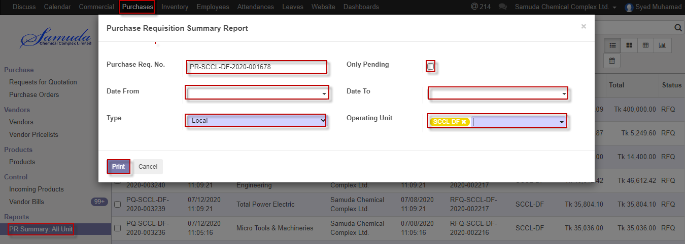

Figure: Purchase Requisition Summary Report print view

We need to set the following:-

**Purchase requisitions No**: Enter PR no.

**Date From:** Select date from.

**Date TO:** Select Date TO.

**Type:** Select type.

**Only pending:** Check.

**Operating unit:** Select operating unit.

After entering all information click **Print**.

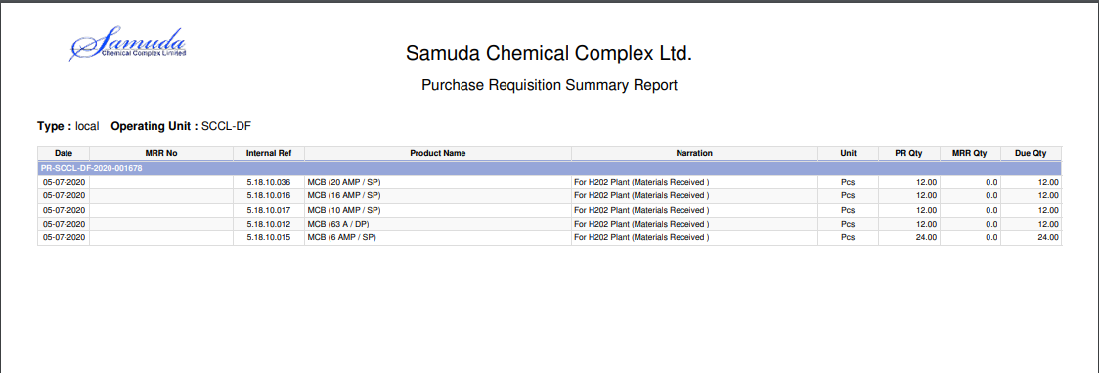

Figure: Purchase requisition summary reports PDF format

## 12.2 Pending purchase local reports view by procurement user/ Manager

To see the Pending purchase local reports use the menu **Commercial ‣ Reports ‣ Pending purchase(local) reports**

Select report thenclick the **Print** button

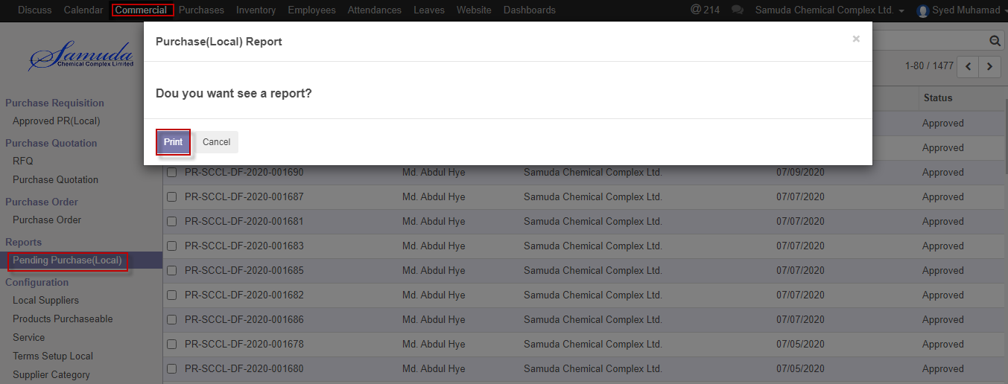

Figure: Pending purchase (local) report print view

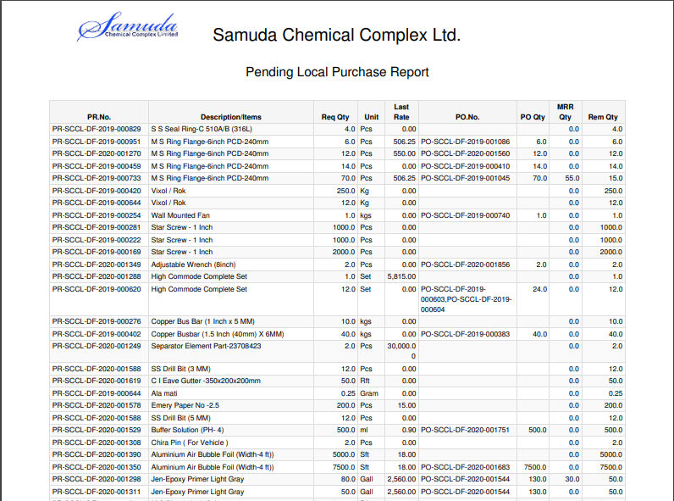

Figure: Pending purchase (Local) reports PDF format